Exhibit A
TBD FM 1690 Gatesville TX 76528
Legal Description: 36 +/- acres out of the Hugh McCrory Survey Abstract No. 704 Exact Acreage and legal description to be determined by survey.
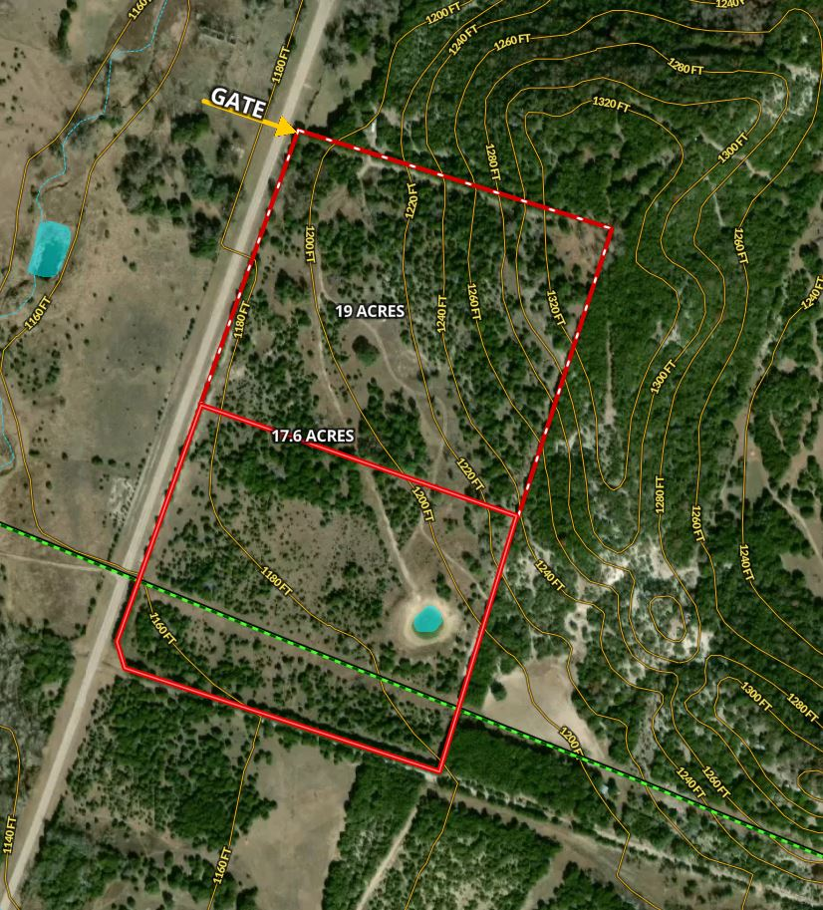

Deed Restrictions:

The following are prohibited:
- any illegal activity,
- any nuisance or noxious or offensive activity;
- any dumping of rubbish or trash, including junk yard or salvage yard
- any vehicles that are non-operable (except for 15 days during repairs),
- any swine or poultry for commercial feedlot purposes,
- no commercial gun range,
- no RV park;
- no Go-cart/ Moto Cross operations
- no used manufactured or modular homes
- no shack-looking or dilapidated sheds
- or any commercial activity except reasonable home office use.

Set backs:
- 50’ building line from property boundary

Initialed for Acknowledgment by Buyer: and Seller:

